Reading Help for the Tabula Peutingeriana

In the Tabula Peutingeriana, you can find the following writing for the letters of the alphabet.

Capitals:
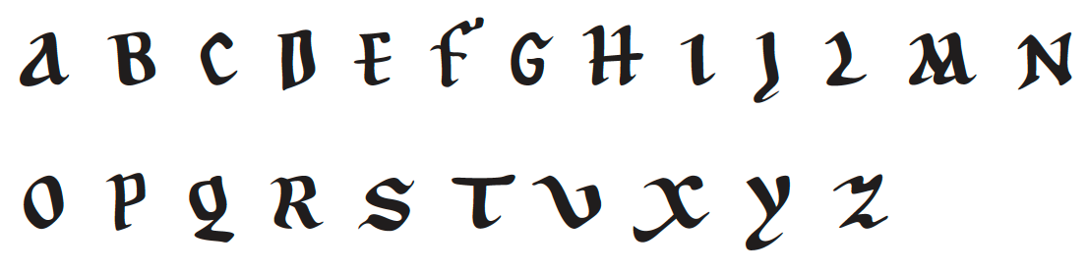
A B C D E F G H I J L M N


O P Q R S T U X Y Z

Small letters:
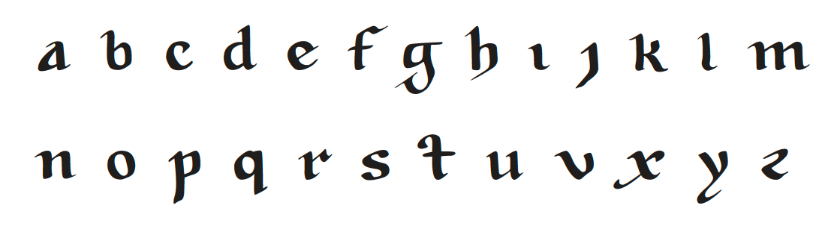
a b c d e f g h i j k l m


n o p q r s t u v x y z

Some variations in the writing of small letters:

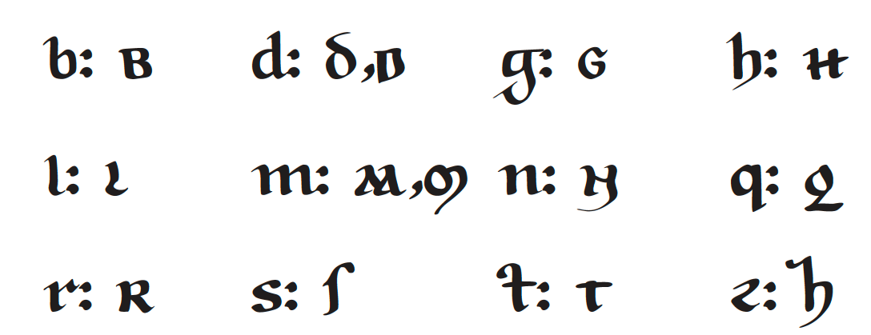

Some variations in the writing of capital letters:

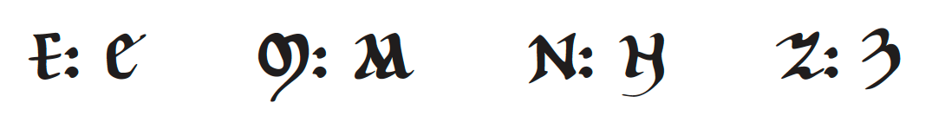

For names of provinces and seas, the following bigger capital letters are used:

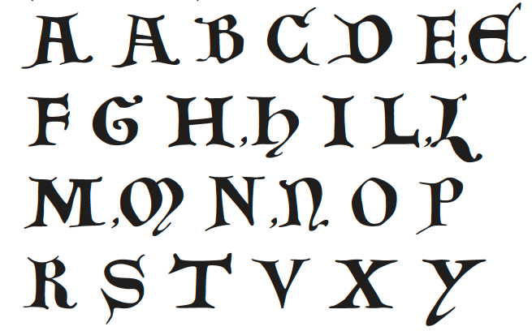

Some abbreviations frequently used in the Tabula Peutingeriana:

